http://w2.vatican.va/content/john-paul-ii/en/apost_exhortations/documents/hf_jp-ii_exh_30121988_christifideles-laici.html
You can read the full text at the Vatican website
Forms of the Lay Apostolate
In 1987, nearly quarter of a century after Vatican II there was a synod on the laity held in Rome. The synod wanted to revisit the teaching of the Council and represent it for a new generation who are also called by God. The following year Pope John Paul II wrote the document “ON THE VOCATION AND THE MISSION OF THE LAY FAITHFUL IN THE CHURCH AND IN THE WORLD” Christifideles Laici (‘The Lay Members of Christ’s Faithful’).

At the heart of Pope John Paul II’s words is the symbol of the vine and the vineyard, and the he offered a way to prayerfully reflect on the relationship between the vine (Christ) and the branches (us).
The Pope wanted the Church to rediscover a sense of communion and find new ways to embody this in a mission of re-evangelizing especially in the countries and places where faith had previously been taken for granted, but were now being put under pressure by secularization. Even though this was written some time ago, it hinted at a ‘new evangelization’ which has become so important for us today.

Although Christifideles Laici was a blend of the previous Council’s teachings it added an emphasis on some aspects of the lay mission which had become important. For example, the role of women in the Church and the appearance of so-called ‘new movements’.
Individual and pair logo
The pope gave these words on the feast of the Holy Family in 1988.
On your own, or with a partner, re-read the English title of the document: “ON THE VOCATION AND THE MISSION OF THE LAY FAITHFUL IN THE CHURCH AND IN THE WORLD”
What do you think are the important words within this title?
Reflect upon what each of these words mean to you.
Do you think that it is important that it was given on the Feast of the Holy Family? If so, why?
The Pope gave this document to the Church over 25 years ago. Why was it important that he specifically talked about the role of women?

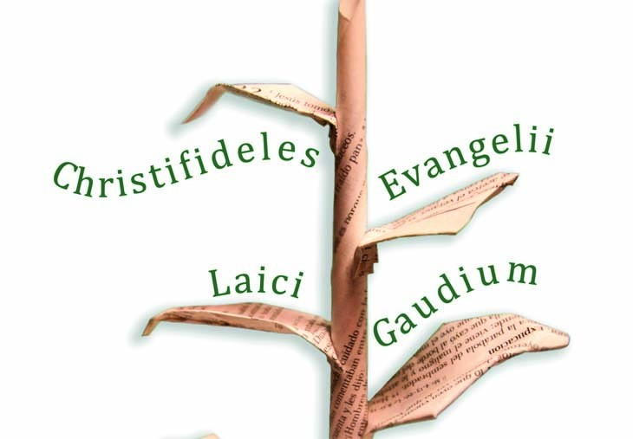

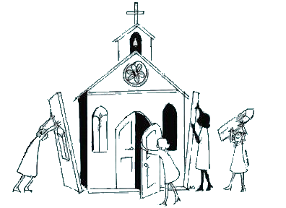
The Role of Women (and men) in the Church
Questions for reflection:
How many women are on your parish council?
Where, when and in what roles do women ‘transmit the faith’ and ‘offer service in the life of the Church’?
In your experience, are women involved in the preparing of documents from the Church?
Is there a role that women play in family, professional and civil life that men cannot?
The Pope was clearly aware that statements of “policy” do not always lead to changes in practices ‘on the ground’ so he gave concrete ways in which women should be involved in decision making processes in the Church.
An example comes to mind in the participation of women on diocesan and parochial Pastoral Councils as well as Diocesan Synods and particular Councils. In this regard the Synod Fathers have written: "Without discrimination women should be participants in the life of the Church, and also in consultation and the process of coming to decisions". And again: "Women, who already hold places of great importance in transmitting the faith and offering every kind of service in the life of the Church, ought to be associated in the preparation of pastoral and missionary documents and ought to be recognized as cooperators in the mission of the church in the family, in professional life and in the civil community". [CL 51]

Questions for reflection:
Do you think that by emphasising the role that women should play, there is a possibility that men feel these roles are no longer theirs?
In your experience, who passes on the faith to their children within the home?
Do you think that there are more women than men who take on roles within the parish these days? If so, why?
How can we ensure that men and women both feel able to be active in their apostolates?
Although the gifts of women are to be employed in the service of the Church, the Synod was also at pains to point out that lay men should not be overlooked.
Many voices were raised in the Synod Hall expressing the fear that excessive insistence given to the status and role of women would lead to an unacceptable omission, that, in point, regarding men. In reality, various sectors in the Church must lament the absence or the scarcity of the presence of men, some of whom abdicate their proper Church responsibilities, allowing them to be fulfilled only by women. Such instances are participation in the liturgical prayer of the Church, education and, in particular, catechesis of their own sons and daughters and other children, presence at religious and cultural meetings, and collaboration in charitable and missionary initiatives. [CL 52]
This is perhaps something we too have come to recognise in many of our parish communities where women far outnumber men in attending Mass and undertaking various duties in and around the parish.
New Movements
“so great is the capacity of initiative and the generosity of our lay people" (Pope John Paul II, Angelus 23/08/87).
There are many groups and organisations that serve the Church through various apostolates. You will have seen them in your Church or heard about them through the work that they do in the parish community. They include: the Legion of Mary, SSVP, UCM, Knights of St Columba, the Catenians, Cenacolo etc.
In recent years these have been added to, complemented and strengthened by the growth of what is known as the ‘New Movements’ within our Church.
Over the past couple of years some of these groups have come to make their home in Scotland and some exciting lay-led initiatives are beginning to bear fruit here in our own Diocese.
Individual or pair tasks:
Do you know of any ‘new movements’ within your Parish, Deanery or Diocese? Who are they and what do they do?
What do you think the Pope means by “responsible participation in the Church’s Mission”?
Do you feel responsible for the Church’s Mission, or do you think that lies with others?
Research one of these ‘New Movements’,. Again think back to the title of the Pope’s document and highlight their particular Vocation and Mission. Outline what is specific about their contribution to the Church and the World.

“Oftentimes these lay groups show themselves to be very diverse from one another in various aspects, in their external structures, in their procedures and training methods, and in the fields in which they work. However, they all come together in an all-inclusive and profound convergence when viewed from the perspective of their common purpose, that is, the responsible participation of all of them in the Church's mission of carrying forth the Gospel of Christ, the source of hope for humanity and the renewal of society.” [CL 29]



Feedback for the Synod

In the first section we looked at the Church teaching on the laity, the Church and their role (apostolate) within it. We have now considered what apostolate women bring to the Church and reflected upon the important role that men continue to play.
We have also researched or read about the New Movements and how these can complement and strengthen the existing, traditional organisations within the Church.
Look back over your reflections and thoughts from the last section.
As a group or individual consider the following questions.
Please record and send your reflections and responses to these questions to the Synod preparatory commission through your nominated representative. (contact details can be found on the Synod website or from your parish bulletin)

How are the gifts of women brought to bear on the life of your parish?
Do we take sufficient account of ‘male spirituality’?
Which lay associations and apostolates are present in your parish? How do they operate and recruit new members? How easy is it to find out about them and join them?
Have you any other comments or questions in response to this section?

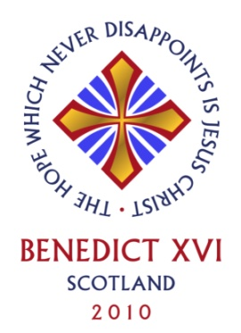
And what about Scotland?
In Scotland we have been blessed to be visited by two successive Popes, St John Paul II and Benedict XVI: both have celebrated large open-air Masses in Bellahouston Park and brought words of real encouragement to us.
Let’s revisit some of the words Pope Benedict gave to us, the Church in Scotland during his recent Papal visit.

Education and Engagement in Society
The Pope spoke about the fact that we have universities that were established by previous Popes, that we have a Catholic schools system that is supported by Government and that Catholics in Scotland can have a great influence through their professional lives, their political engagement and their contribution to culture.
Among the differing gifts which Saint Paul lists for the building up of the Church is that of teaching (cf. Romans 12:7). The preaching of the Gospel has always been accompanied by concern for the word: the inspired word of God and the culture in which that word takes root and flourishes. Here in Scotland, I think of the three medieval universities founded here by the popes, including that of Saint Andrews which is beginning to mark the 600th anniversary of its foundation. In the last 30 years and with the assistance of civil authorities, Scottish Catholic schools have taken up the challenge of providing an integral education to greater numbers of students, and this has helped young people not only along the path of spiritual and human growth, but also in entering the professions and public life. This is a sign of great hope for the Church, and I encourage the Catholic professionals, politicians and teachers of Scotland never to lose sight of their calling to use their talents and experience in the service of the faith, engaging contemporary Scottish culture at every level.
Did you know that 3 of our universities had been founded by Pope’s? Does this make you view them in a different light? If so, why?
Do you think that we take ‘free’ Catholic schools for granted in Scotland? How could we each support the role they play in the Church more?
Think back two generations within your own family. Were Catholics able to take up the professional roles they now do in Scotland? If not, why not? What has changed?
Do Scottish Catholics use their professional and political lives at the service of the faith?
What can we do to encourage Scottish Catholics to be examples of faith in every day life?
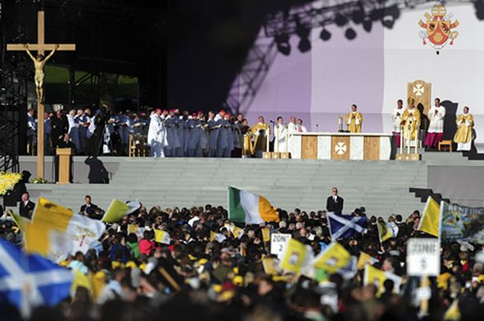

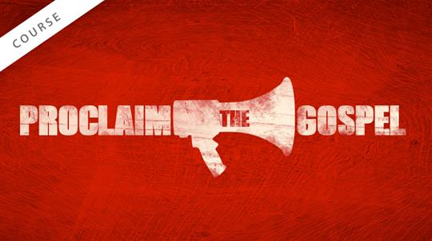
Speaking Out
Pope Benedict then went on to not just be examples of faith, but to be vocal in promoting faith:
I appeal in particular to you, the lay faithful, in accordance with your baptismal calling and mission, not only to be examples of faith in public, but also to put the case for the promotion of faith’s wisdom and vision in the public forum...Do not be afraid to take up this service to your brothers and sisters, and to the future of your beloved nation…
On your own, with your family or as a group, talk about the reasons why you are sometimes afraid to be vocal about your faith.
Share some ideas and words of encouragement with each other to offer strength and support for those times when you want to promote your beliefs, but are anxious or scared to.

Peer to Peer Evangelisation

Pope Benedict finished with some words aimed especially at the young people who were gathered there in such great numbers:
Finally, I would like to say a word to you, my dear young Catholics of Scotland. I urge you to lead lives worthy of our Lord (cf. Ephesians 4:1) and of yourselves.
There are many temptations placed before you every day - drugs, money, sex, pornography, alcohol - which the world tells you will bring you happiness, yet these things are destructive and divisive. There is only one thing which lasts: the love of Jesus Christ personally for each one of you. Search for him, know him and love him, and he will set you free from slavery to the glittering but superficial existence frequently proposed by today’s society. Put aside what is worthless and learn of your own dignity as children of God. In today’s Gospel, Jesus asks us to pray for vocations: I pray that many of you will know and love Jesus Christ and, through that encounter, will dedicate yourselves completely to God, especially those of you who are called to the priesthood and religious life. This is the challenge the Lord gives to you today: the Church now belongs to you! [Pope Benedict XVI, Homily in Bellahouston Park, 16 September 2010]
Reread the words of the Pope to the young people of Scotland. In a small group, decide on three key messages that the Pope wants to give to our young people. Write these on large pieces of paper. Arrange the paper in order, starting from the most important and hang them, like bunting, as a way to remind people of what the Pope is teaching us.


Echoes of the Past
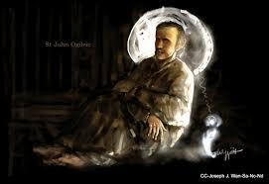
Many of these themes were echoed by Bishop John in his homily for the 2015 Chrism Mass in the Cathedral. Recalling the 400th anniversary of the martyrdom of St John Ogilvie, Bishop Keenan spoke of St John’s personal search for the Lord which led him, gradually but irrevocably to the Catholic Church.
The search caused him a lot of anxiety as it began to dawn on him that the only truth by which he and the world could be saved was the Catholic faith. Here was the true Church of Christ, where the Saving Lord still lived on earth. Only here in the Catholic Church was there to be found that living, unbroken link with the Lord; only this Church included everyone of every rank and race across the world; in the Catholic Church there was testimony of ample and wonderful miracles; only this Church had truly satisfied the minds of the wisest; and it was for the Holy Catholic Church that he had heard so many martyrs had laid down their lives. He converted to it with a personal passion but soon it blossomed into a pastoral compassion for his homeland and a certainty that, if the soul of the Scottish nation were to be saved and live, it could never be just by some mere political arrangement but would be so only through the ministry of Catholic priests who would restore the redeeming light and grace of the true faith to our shores. Then, and only then, would Scotland really and truly be a nation at peace with itself.
Individual or pair task
- Only here in the Catholic Church was there to be found that living, unbroken link with the Lord;
- only this Church included everyone of every rank and race across the world;
- in the Catholic Church there was testimony of ample and wonderful miracles;
- only this Church had truly satisfied the minds of the wisest;
- and it was for the Holy Catholic Church that he had heard so many martyrs had laid down their lives
Look at each of the statements above, taken from Bishop John’s sermon.
Reflect upon this question: “Do I recognise this as a description of the Catholic Church in Scotland, in Paisley, today?”
Individually or in pairs, talk through each of the bullet points and share your thoughts on whether or not these are true reflections of our Church today.
Take time to pray that, those aspects of the Church that you do not recognise above, may become more visible to the world today through the apostolate and mission of the laity.

Hope for the future?
St. John Ogilvie’s life and martyrdom continue to inspire us today. Through his witness, generations of priests dedicated themselves to carrying on his mission. Through their work and ministry, the Church in Scotland was able to re-establish itself. Among the fruits of this mission was a Laity which was well-formed and who understood the spirit of sacrifice which characterised their priests. As Blessed John Henry Newman wrote, ‘in all times the laity have been the measure of the Catholic spirit’ (Duties of Catholics, 4).
Today Scotland continues to need the renewing power of the Gospel to be at work. The strong voice of St. John Ogilvie in the public square and the Christians he inspired can no longer be heard in the media, social networking, at work, during social events and even within the family. When we do try to make our voices heard we can be drowned out by louder, yet significantly smaller groups and we seem to lose confidence in our message. Sometimes it is hard to overcome the hurt that has been felt throughout the Church in recent years and we wonder if we should be speaking out on behalf of the Church. Other times we do not feel confident in our own ability to share the teaching of the Church, so instead we stay quiet. There are also times when we feel that the voice of the Christian will be ridiculed by the secular voices that seem to spend great time and energy targeting our beliefs, practices and contribution to culture and society.
Although Bishop John’s words were addressed in the first instance to priests, they are equally for the lay members of our Parish communities. This Synod is an important step in refreshing our Church and strengthening our shared witness to the Lord.
Feedback for the Synod:
Look back over your reflections and thoughts from the last section.
As a group or individual consider the following questions.
Please record and send your reflections and responses to these questions to the Synod preparatory commission through your nominated representative.
(contact details can be found on the Synod website or from your parish bulletin)
In announcing Vatican II, St John XXIII set the Council the task of reading the signs of the times and responding to them in ways which were both faithful to the Gospel and yet adapted to the rapid (and sometimes terrifying) changes which had come about in the first half of the 20th Century. The teaching of the Council is still embedding itself, even as the world continues to come to terms with these changes in the first years of the next century. Scotland (and the Church in Scotland) is no exception to this.
What are the ‘signs of the times’ which we must be able to read in 21st century Scotland, both as a nation and as a Church?
Have you any other comments or questions in response to this section?

****For after the concluding prayer*****

Appendix A
The Church-Further Reading
Of the many metaphors and symbols of the Church, we could perhaps focus on two: the Church as herald of the Kingdom and as the Body of Christ.
Jesus came to proclaim (and bring about) the Kingdom – or Reign – of God. Time and again his activity in the Gospel is centred on making God’s sovereignty of love, justice and holiness a reality in our world. In a sense, everything he does and says is directed towards achieving that end. Paragraphs 763-766 of the Catechism set out this teaching very clearly for us.

763 It was the Son's task to accomplish the Father's plan of salvation in the fullness of time. Its accomplishment was the reason for his being sent. “The Lord Jesus inaugurated his Church by preaching the Good News, that is, the coming of the Reign of God, promised over the ages in the scriptures." To fulfil the Father's will, Christ ushered in the Kingdom of heaven on earth. The Church "is the Reign of Christ already present in mystery."
764 "This Kingdom shines out before men in the word, in the works and in the presence of Christ." To welcome Jesus' word is to welcome "the Kingdom itself." The seed and beginning of the Kingdom are the "little flock" of those whom Jesus came to gather around him, the flock whose shepherd he is. They form Jesus' true family. To those whom he thus gathered around him, he taught a new "way of acting" and a prayer of their own.
765 The Lord Jesus endowed his community with a structure that will remain until the Kingdom is fully achieved. Before all else there is the choice of the Twelve with Peter as their head. Representing the twelve tribes of Israel, they are the foundation stones of the New Jerusalem. The Twelve and the other disciples share in Christ's mission and his power, but also in his lot. By all his actions, Christ prepares and builds his Church.
766 The Church is born primarily of Christ's total self-giving for our salvation, anticipated in the institution of the Eucharist and fulfilled on the cross. "The origin and growth of the Church are symbolized by the blood and water which flowed from the open side of the crucified Jesus." "For it was from the side of Christ as he slept the sleep of death upon the cross that there came forth the 'wondrous sacrament of the whole Church.'" As Eve was formed from the sleeping Adam's side, so the Church was born from the pierced heart of Christ hanging dead on the cross.
This section speaks of the Church as a ‘seed’ of the Kingdom which grows according to God’s good pleasure and loving providence. But it also offers us the idea that Jesus gave the Church, in the apostles and their followers, a structure. So it is that the community of believers has a form, an order as well as a purpose. We believe that this structure continues to this day in the Church under the leadership of the Pope, as successor of Peter and the Bishops as successors of the apostles. This reality, sometimes described with the unflattering title of ‘the institutional Church’ really refers to the ‘little flock’ the Lord gathered to himself. All authority in the Church is essentially pastoral in nature (i.e. pertaining to shepherds) rather than the worldly model of power and prestige.
The Church is, therefore, a foreshadowing of the full reality of the Kingdom of God: it proclaims the Beatitudes and the Lord’s preferential love for those on the margins of life. It is, as CCC 766 pointed out, a community which flows from Jesus’ saving death on the cross. The sacraments flow from the mystery of the Paschal Sacrifice of Jesus and the community of believers is nourished, kept safe and enriched by the graces we receive through these signs. Above all, the blood and water flowing from the side of Jesus make us think especially of the sacraments of Baptism (by which we become members of the Church) and the Eucharist (by which we receive and become the Body of Christ).
Of all the ways of describing and thinking about the Church, perhaps none is as important as the Body of Christ. It is, in fact, probably the earliest theological expression for the Church since we find it in the writings of St. Paul. This is what the Catechism says:
787 From the beginning, Jesus associated his disciples with his own life, revealed the mystery of the Kingdom to them, and gave them a share in his mission, joy, and sufferings. Jesus spoke of a still more intimate communion between him and those who would follow him: "Abide in me, and I in you.... I am the vine, you are the branches" (John 15:4-5) and he proclaimed a mysterious and real communion between his own body and ours: "He who eats my flesh and drinks my blood abides in me, and I in him." (John 6:56)
788 When his visible presence was taken from them, Jesus did not leave his disciples orphans. He promised to remain with them until the end of time; he sent them his Spirit. As a result communion with Jesus has become, in a way, more intense: "By communicating his Spirit, Christ mystically constitutes as his body those brothers of his who are called together from every nation."
789 The comparison of the Church with the body casts light on the intimate bond between Christ and his Church. Not only is she gathered around him; she is united in him, in his body. Three aspects of the Church as the Body of Christ are to be more specifically noted: the unity of all her members with each other as a result of their union with Christ; Christ as head of the Body; and the Church as bride of Christ.
790 Believers who respond to God's word and become members of Christ's Body, become intimately united with him: "In that body the life of Christ is communicated to those who believe, and who, through the sacraments, are united in a hidden and real way to Christ in his Passion and glorification." This is especially true of Baptism, which unites us to Christ's death and Resurrection, and the Eucharist, by which "really sharing in the body of the Lord… we are taken up into communion with him and with one another."
791 The body's unity does not do away with the diversity of its members: "In the building up of Christ's Body there is engaged a diversity of members and functions. There is only one Spirit who, according to his own richness and the needs of the ministries, gives his different gifts for the welfare of the Church." The unity of the Mystical Body produces and stimulates charity among the faithful: "From this it follows that if one member suffers anything, all the members suffer with him, and if one member is honoured, all the members together rejoice." (cf. 1 Corinthians 12:26) Finally, the unity of the Mystical Body triumphs over all human divisions: "For as many of you as were baptized into Christ have put on Christ. There is neither Jew nor Greek, there is neither slave nor free, there is neither male nor female; for you are all one in Christ Jesus." (Galatians 3:27-28)
The Catechism gets to the heart of the very intimate connection that exists between Christ, the Head of the Body and his members. St Paul is at pains to point out that the various parts of the body need each other, each with a different but important function. So it is that the different members of the Church have a variety of gifts, given by the Holy Spirit, but intended for the benefit of all. The body grows in strength when these gifts (‘charisms’) are put to good use: as Paul says, ‘there is a variety of service to be done, but always to the same Lord.’ (1 Corinthians 12:5)

